Machrihanish Seabird Observatory
Established 1993
25th Year
June Report 2018
Compiled by Eddie Maguire - msbowarden@gmail.com
Tel. – 07895 952640
Website – www.machrihanishbirdobservatory.org.uk

Photo of the Month...
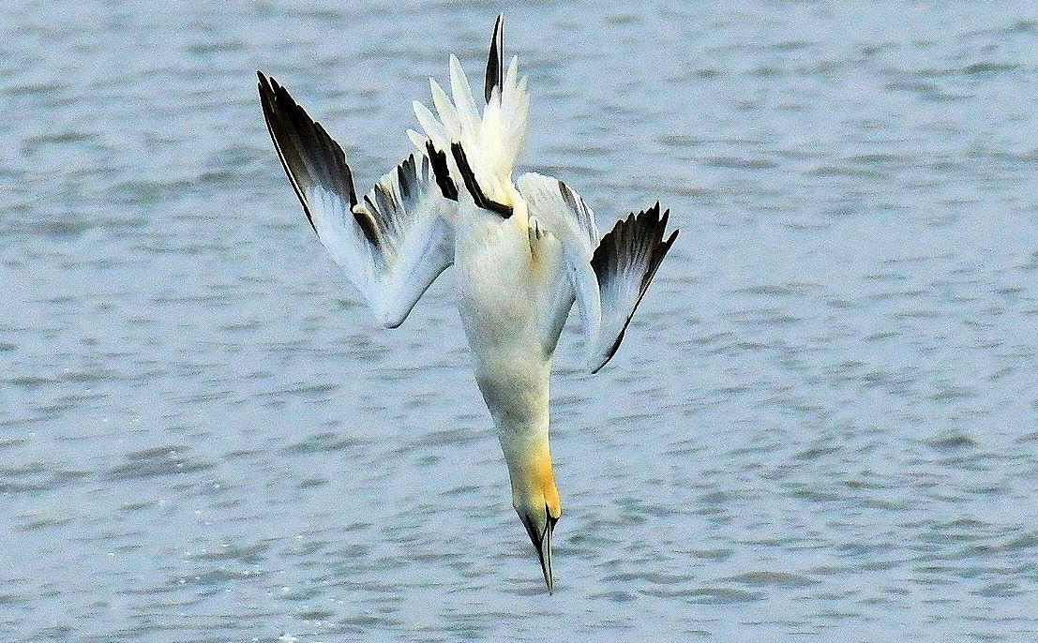
Sub-adult Northern Gannet foraging off MSBO 16th June

Introduction...
The June Report includes records / summary photographs from MSBO along with sightings from around Kintyre by a few regular contributors.
Surveillance of Northern Gannets crossing 8km overland to the west from Campbeltown Harbour to Machrihanish Bay was sustained throughout June. This matchless ongoing MSBO project will continue through to October.

Birdwatching in Argyll...
To find out what birders are reporting daily (including photographs) and migrant arrival dates visit Argyll Bird Club’s website at www.argyllbirdclub.org
List of Selected Species...

Common Shelduck
Breeding; ducklings just hatched included b/6 on 5th, b/3 on 7th, b/7 on 13th and a b/1 + a b/3 on 15th. Note; the b/10 that hatched on 30th May is doing very well indeed; the brood was seen many times up to 26th June and all have managed to survive.

Table 1.
Common Shelduck productivity at Machrihanish during May / June 2016 – 2018.

Year | No. broods | No. ducklings | Mean brood size
2018 | 6 | 30 | 6
2017 | 8 | 55 | 6.7
2016 | 6 | 37 | 6.1

The topmost duckling productivity at Machrihanish occurred in 2010 when 75 (9 broods) hatched during April /June. On 9th June that year, a pair in charge of a remarkable assembly of 19 tiny ducklings (just hatched) appeared (apparently several females often dump eggs in a single nest). Excluding this crèche pair the average brood size in 2010 was 7 (8 broods / 56 ducklings).

Gadwall
Two eclipse males arrived on 29th and were still present on 30th – a rare summer occurrence.

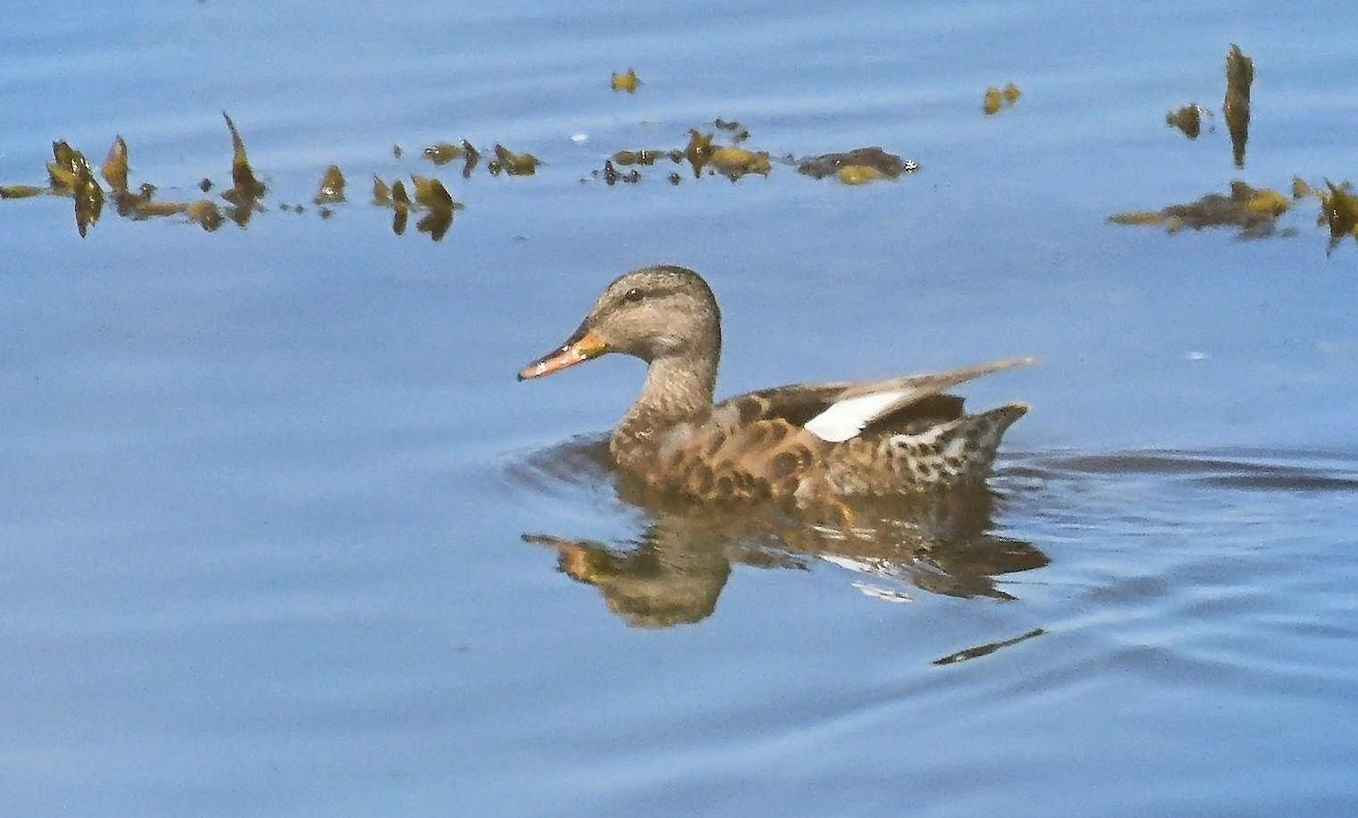
Gadwall: eclipse male 29th June

Common Eider
Breeding; ducklings just hatched included b/5 on 2nd, b/2 on 7th, b/6 on 10th, b/4 on 13th and b/3 on 26th. On 15th, 7 females with a creche of 10 very small ducklings appeared by MSBO. The largest ducklings (4) were probaby the b/4 from 13th so were omitted from the table below. When the broods split up the smaller ducklings looked good for b/3s; these were added to the no. of broods in the table below.
Table 2
Common Eider productivity at Machrihanish during May / June 2016 – 2018.

Year | No. broods | No. ducklings | Mean brood size
2018 | 8 | 25 | 3.1
2017 | 6 | 23 | 3.5
2016 | 10 | 35 | 3.5

The topmost duckling productivity at Machrihanish occurred in 2010 when 94 ducklings were hatched during April / July. Excluding a mixed age crèche of 35 ducklings the average brood size was 3.7 (16 broods / 59 ducklings).
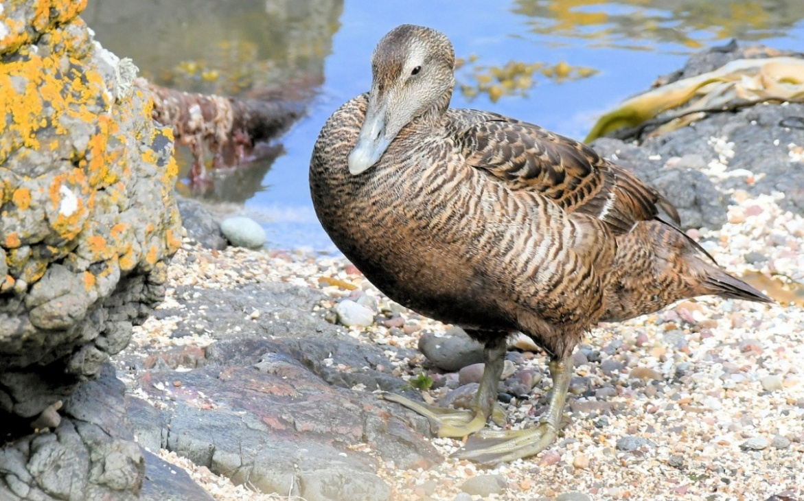
Common Eider MSBO 20th June

Common Scoter
Flocks >S included ca. 30 males on 6th, 7 males on 16th and 8 (5 males) on 23rd. A female was resting in Machrihanish Bay on 29th.
Passage total at MSBO; 45 birds >S on 3 dates during June.
This species is a regular June passage visitor in variable numbers and flocks usually consist mainly of males.
Sound of Gigha; 51 on 26th (Jim Dickson pers. comm.).

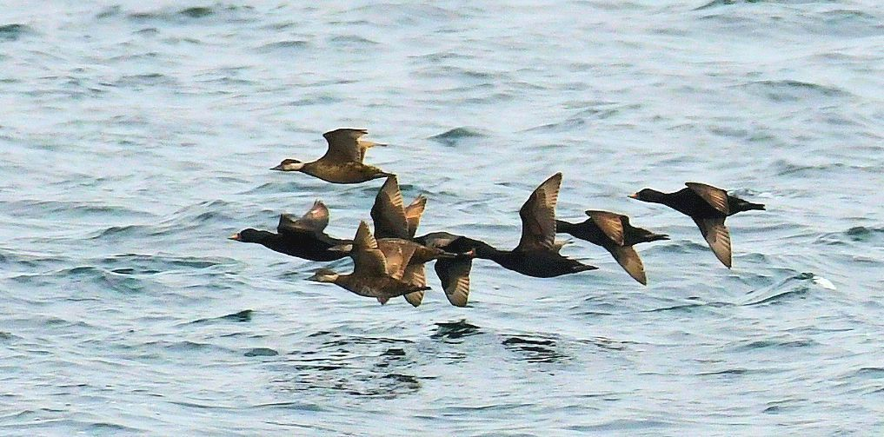
Common Scoters on passage 23rd June

Red-breasted Merganser
Flock 14 >S on 14th. Sound of Gigha; flock 290 on 26th (Jim Dickson pers. comm.).

Northern Gannet
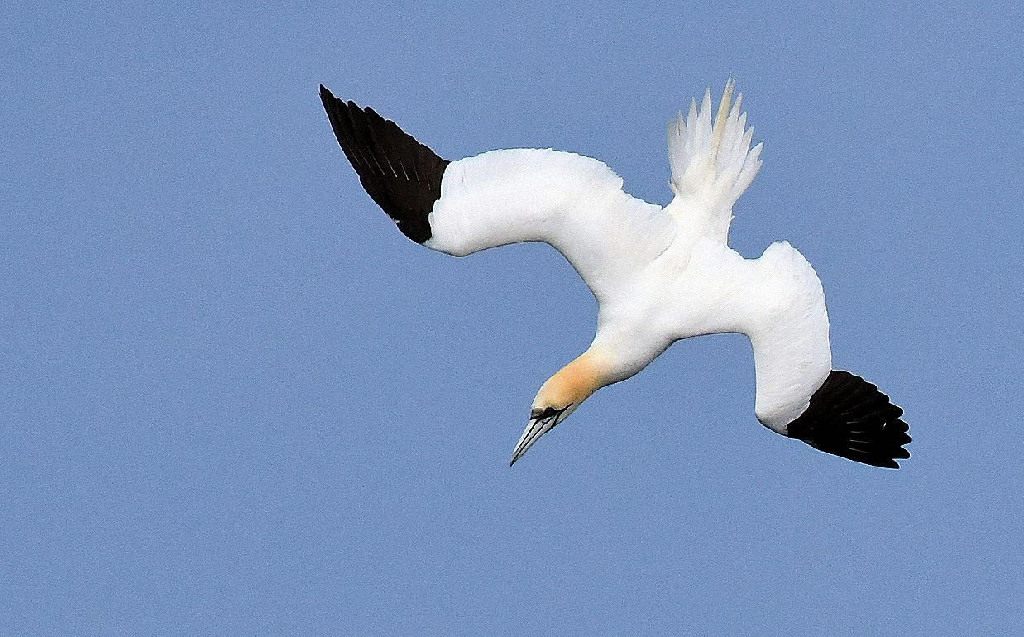
Adult Northern Gannet foraging off MSBO 16th June

Monitoring westerly overland passage of Northern Gannets - an ongoing MSBO Project...
During June, a total of 336 adults crossed west over Kintyre on 28 / 30 days of observation.
Table 3. Daily totals of adult Northern Gannets flying 8km overland from Campbeltown Harbour (Clyde waters) to Machrihanish Bay (Atlantic) during June along with wind direction/force and departure times of first/last bird.

June | Number  Adults  crossing  overland | Wind  Direction  &  force | Campbeltown  Departure  times of  first / last bird
1st | 62 | Variable 1 | 12:07 – 20:10
2nd | 17 | Variable 1 | 11:20 – 20:47
3rd | 10 | Variable 1 | 15:59 – 21:45
4th | 42 | S 2 | 12:42 – 20:13
5th | 26 | E 1 | 12:20 – 21:10
6th | 4 | Variable 1 | 13:56 – 17:29
7th | 19 | Variable 1 | 14:35 – 20:55
8th | 11 | NW 2 | 11:50 – 21:18
9th | 13 | W 1 - 2 | 11:52 – 20:40
10th | 9 | W 2 | 12:05 – 22:10
11th | 6 | W 2 | 11:50 – 20:27
12th | 3 | W 2 | 19:45 – 1956
13th | 4 | SE 3 - 4 | 14:28 – 14:55
14th | 7 | W 8 | 10:52 – 17:28
15th | 17 | SW 3 | 11:23 – 15:32
16th | 12 | W 2 | 12:47 – 19:18
17th | 1 | SW 4 | 17:05
18th | 23 | SW 2 | 10:46 – 18:47
19th | 3 | W 2 | 11:13 – 14:28
20th | 13 | W 3 | 14:13 – 18:17
21st | 14 | WNW 4 | 13:40 – 20:10
22nd | 5 | NW 3 | 11:15 – 20:47
23rd | 2 | W 3 | 14:00 – 20:13
24th | 0 | Variable 1 | –
25th | 3 | Variable 1 | 11:28 – 20:49
26th | 0 | Variable 1 | –
27th | 3 | Variable 1 | 14:23 – 14:26
28th | 1 | Calm | 15:38
29th | 5 | W 2 | 09:28 – 09:29
30th | 1 | ESE 2 - 3 | 12:08
Total | 336

From March to June 2018 a total of 465 adult Northern Gannets crossed overland on 75 / 122 days of surveillance
The table below compares the numbers of Northern Gannets that crossed west over Kintyre during March – October 2017 with this seasons totals so far.
Table 4.
2017 | March | April | May | June | July | Aug | Sept | Oct
Monthly totals | 2 | 23 | 131 | 126 | 274 | 408 | 491 | 6
Cumulative totals | 2 | 25 | 156 | 282 | 556 | 964 | 1,455 | 1,461
2018 | March | April | May | June | July | Aug | Sept | Oct
Monthly totals | 6 | 45 | 78 | 336
Cumulative totals | 6 | 51 | 129 | 465

Northern Gannets crossing Kintyre
Factfile...

- South Kintyre is the only accredited location in the UK where Gannets routinely cross overland during the breeding season, often in significant numbers, presumably to gain rapid access to foraging grounds.
- Only adults have crossed the low-lying 8km overland route from Campbeltown to Machrihanish Bay and to date, the overland passage is strictly one way – to the west (Clyde > Atlantic).
- Gannets flying to the west over Campbeltown look aerodynamic and are evidently at minimal weight which must obviously be a huge advantage when crossing west over S Kintyre.
- Gannets employ powered flight (sustained flapping) to cross the 8km at around 35 mph and the crossing has been timed on a regular basis at a constant 9 mins.
- After foraging successfully, Gannets are burdened significantly with fish prey, are visibly bloated and evidently at top weight; therefore, it is improbable that they would attempt to return overland from Atlantic to Clyde. Birds then rely on a marine route return journey to the colony and employ powered flight in concert with dynamic soaring (wave power) to accomplish this.
- There is a substantial increase in the numbers of Gannets that cross west over Kintyre in August and September (see 2017 data in Table 4 above); presumably this indicates urgency by breeding adults from the Ailsa Craig colony to gain access to foraging grounds in the Atlantic as this period coincides with the final stages of the breeding season when increasing food demands of large chicks reach their peak.
- The record number crossing to the west in a single day = 67 in September 2017.
- The largest flock seen crossing to the west = 16 in September 2017.
- Wind direction appears to have little / no influence on the numbers that embark on this low-lying overland shortcut to the Atlantic.
- Wind strength does not dissuade crossings either; a high total of 50 birds >W on 19th August 2017 in a WNW force 6.
- Gannets have never been recorded crossing west over Kintyre during the main winter period (November – February).
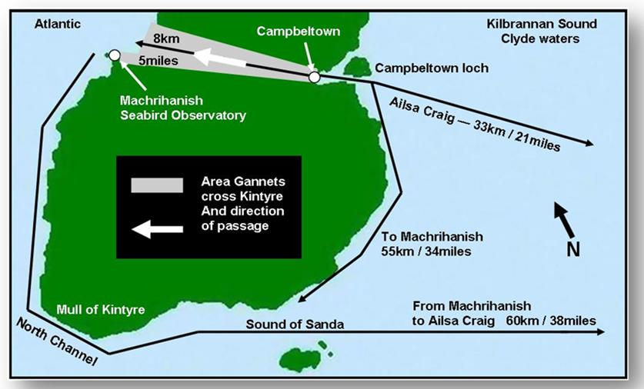

Figure 1. South Kintyre, Argyll showing the westerly overland route (8 km / 9 minute flight) taken by adult Northern Gannets from Campbeltown Loch harbour (Clyde waters) to Machrihanish Bay (Atlantic). Direct marine routes with approximate distance from Campbeltown Loch to Machrihanish and the Ailsa Craig colony are also shown.
A paper by Eddie Maguire / Charlie Robertson relating to studies of overland passage of this species during 2017 entitled ‘Northern Gannets crossing overland in South Kintyre, Argyll’ was recently published in the Seabird Group Newsletter (Number 137 / February 2018) and in Argyll Birds Club’s Newsletter The Eider (Number 123 / March 2018).

Great Northern Diver
Birds in non-breeding plumage included singles on 6th and 15th. On 25th, 3 appeared offshore; two were in partial breeding plumage.
Campbeltown Loch; a lingering adult (breeding plumage) was present to at least 9th (Brian Morton pers. comm.).

Oystercatcher
Breeding; two pairs (one failed at egg stage). First eggs hatched 6th June and two chicks ringed on 13th.

Dunlin
Four on 2nd and one on 4th. A flock of 43 arrived on 9th and a flock 14 on 12th; the birds in both flocks were all in breeding plumage, had long bills / bright rufous upperparts which, along with the late passage dates, suggest northern breeders, perhaps nominate alpina?
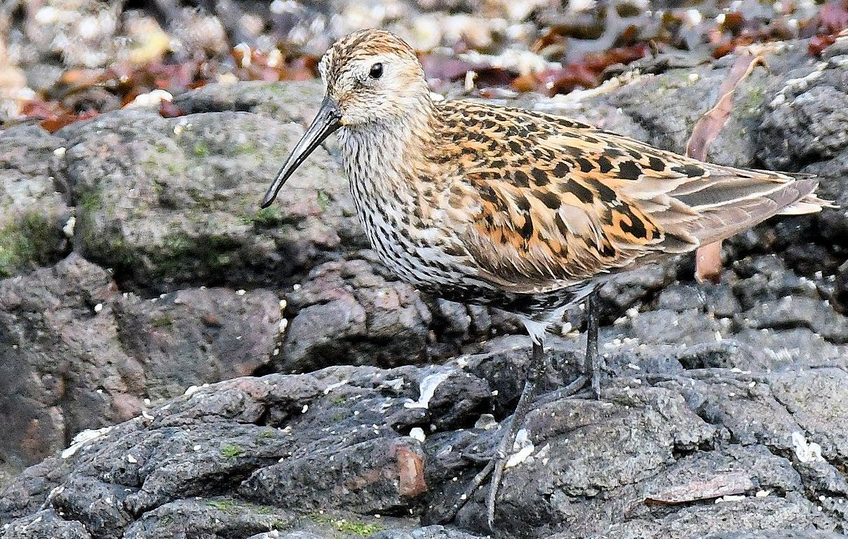
Dunlin 12th June

Ruddy Turnstone
Three arrived on 15th – a scarce mid-summer occurrence.

Red Knot
One in non-breeding plumage rested for a few hrs on 19th – a most unusual mid-summer occurrence.
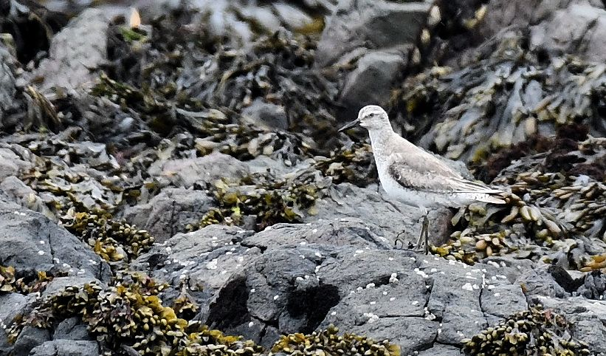
Red Knot (non-breeding plumage) 19th June
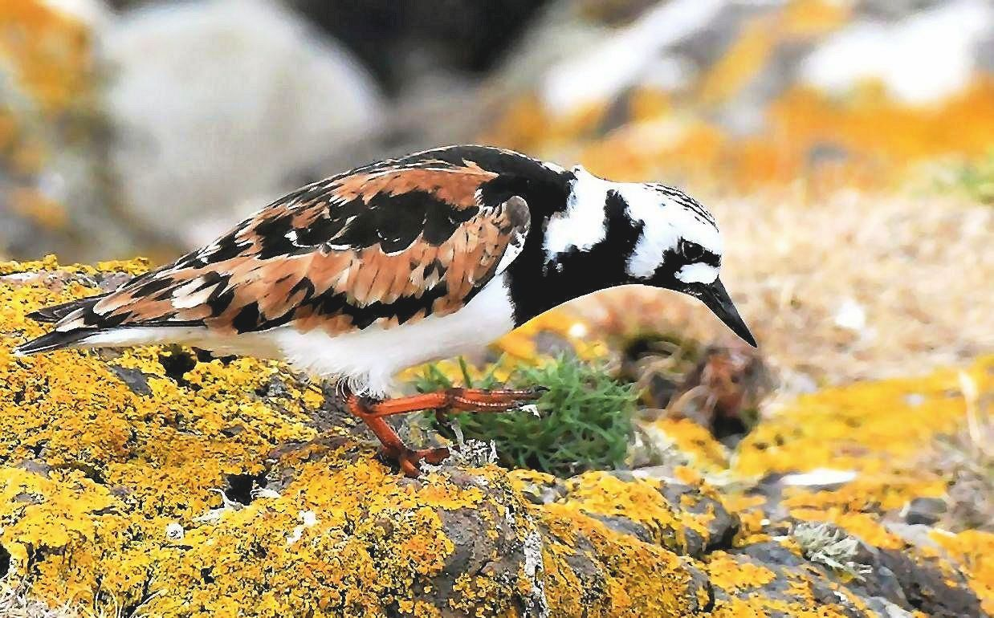
Ruddy Turnstone (breeding plumage) 15th June

Sanderling
Sixty were resting on 4th, 10 >S on 8th, 7 resting on 10th, 8 >S on 14th.
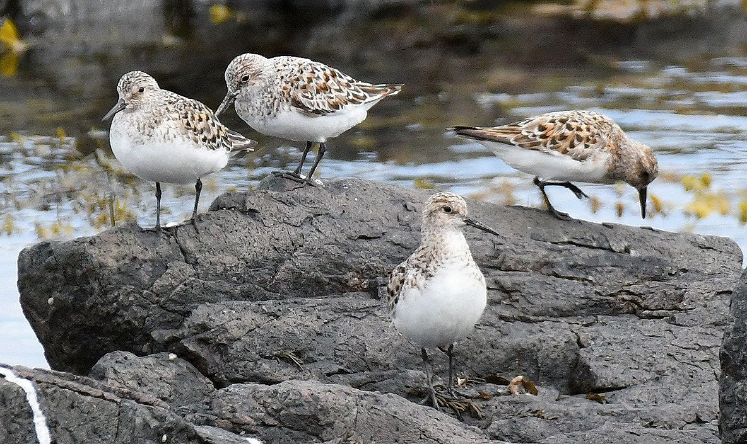
Sanderlings 10th June

Common Sandpiper
Breeding; pair with b/3 on 20th.

Whimbrel
One present daily 1st – 5th and one on 29th – the latter a scarce summer occurrence.
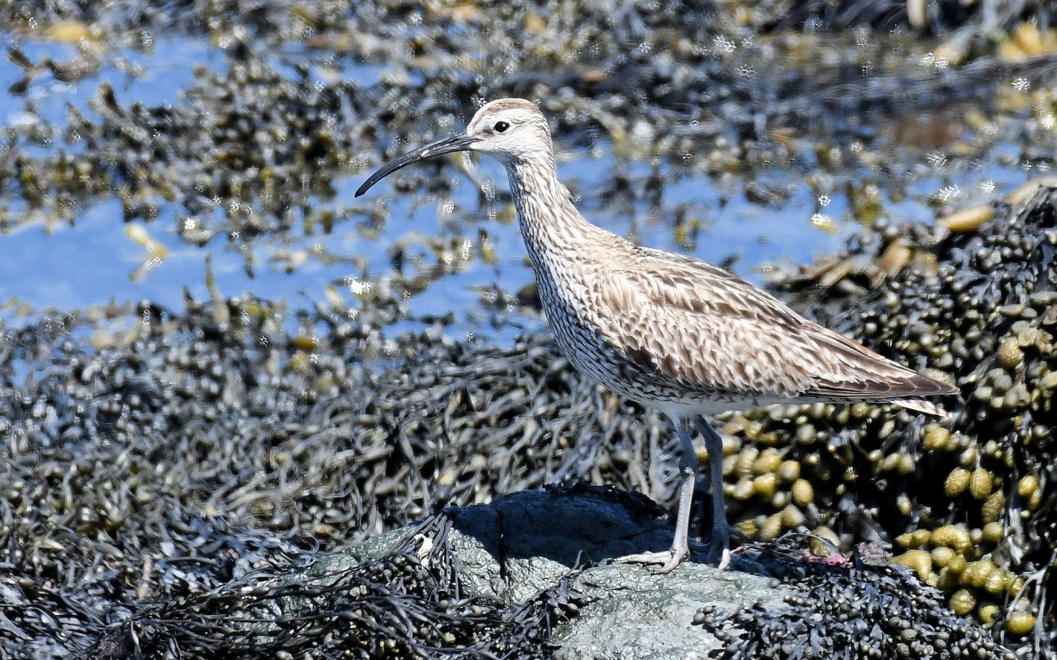
Whimbrel 29th June

Arctic Skua
Single dark phase adults >S on 11th and 14th - a rather scarce June visitor.
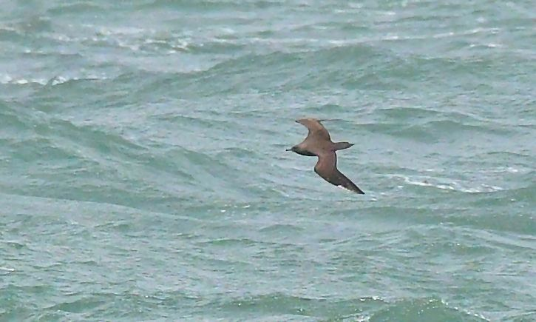
Arctic Skua 14th June

Common Gull
Breeding; nest by MSBO; b/3 hatched on 11th. The chicks had vanished by 14th.

Mediterranean Gull
An immaculate breeding plumaged adult on 1st was flying south so close to MSBO (on the doorstep) that any notion of obtaining a photo was pointless.

Herring Gull
The leucistic adult was seen frequently throughout the month.
Breeding; pair failed at egg stage by MSBO. Campbeltown; roof nesting pairs are now at the chick stage at Davaar Ave, Calton Ave and Albyn Ave. 6 - 8 pairs nested (Davie Robertson pers. comm.). Many more pairs are nesting throughout the town.

Iceland Gull
A 2CY arrived on 15th and was present to 22nd – another rare mid-summer occurrence following summering immatures at MSBO and The Laggan last year.
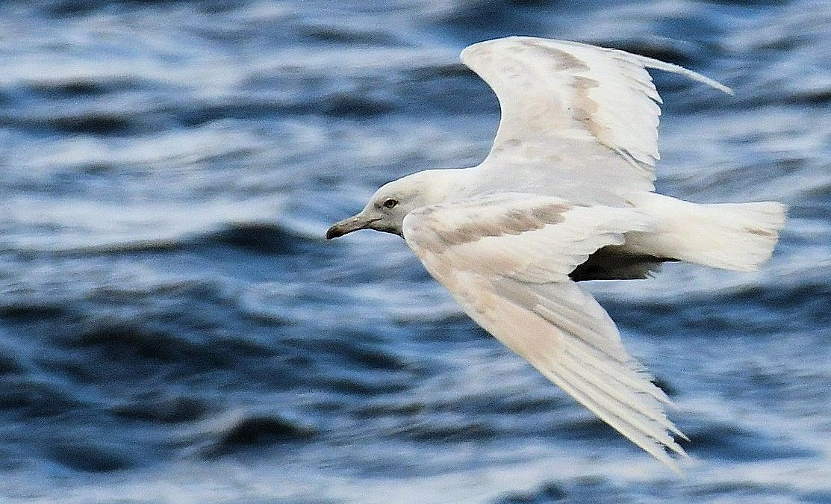
2CY Iceland Gull off MSBO 21st June

Sandwich Tern
Present daily in small numbers; max counts 9 on 7th, 10 on 14th and 11 on 22nd.
Southend; 12 on 10th (Dee Brodie pers. comm.).

Arctic Tern
Breeding; ca. 8 pairs nesting on Big Scone Island off the village. Small chicks were seen being fed on 22nd.

Common Tern
Breeding; 6 arrived at the Arctic Tern colony on 10th.

Common Swift
Breeding; main activity centered around Saddell St (by Tesco) and 125 Longrow (by the Co-op). Also, several pairs are under roans at George St (Dalintober).

Northern Wheatear
Breeding; 4 chicks fledged by MSBO on 1st.

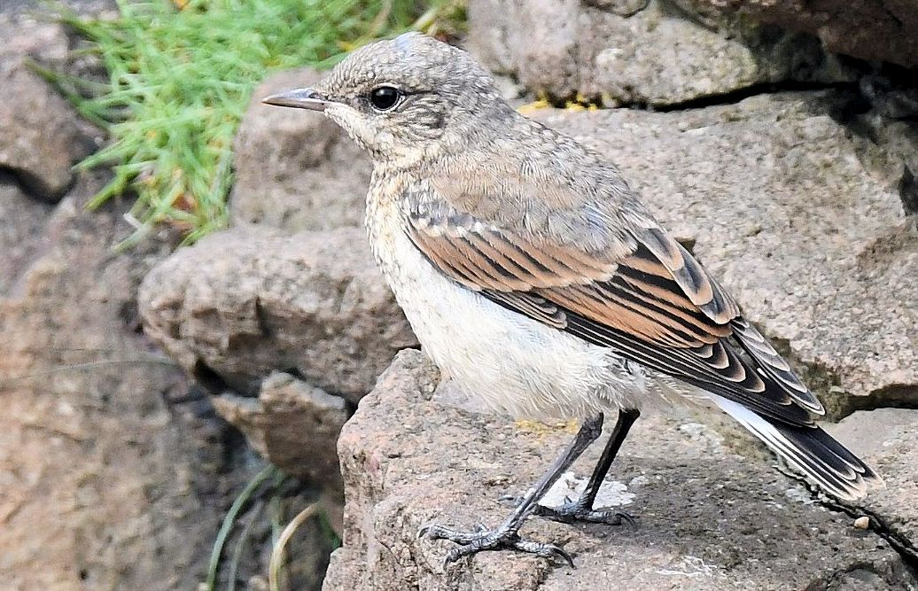
Northern Wheatear (fledgling) MSBO 15th June

Rock Pipit
Breeding; a pair feeding 4 fledglings on 26th.

Pied Wagtail
Breeding; at MSBO a pair nested between the open (hooked-up) wooden hatch and the roof of the viewing platform. The clutch (5) hatched on 19th (photos below).
This is likely the second brood of a pair that bred sucessfully close by in late April / May.

Starling
A flock of up to 80 juveniles foraged on the shore all month

Twite
A singing male on 19th was the sole record.
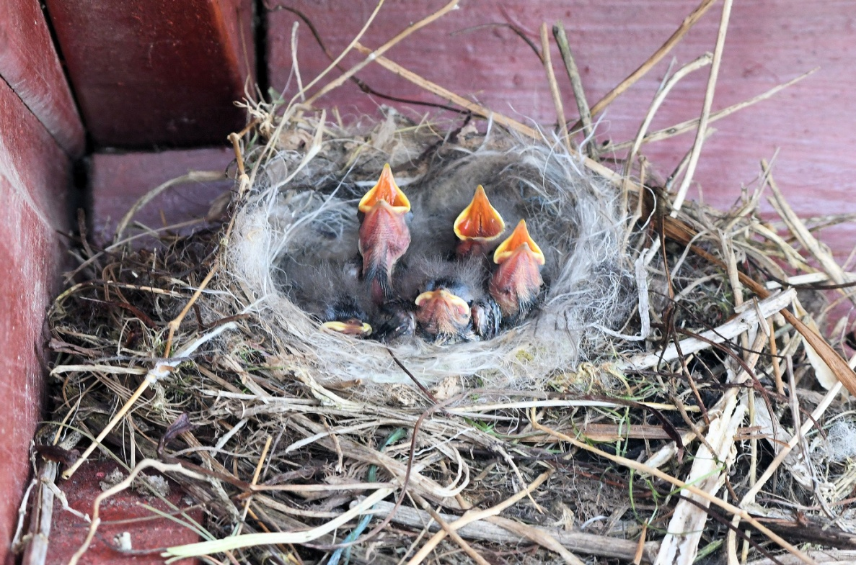
Pied Wagtail nest at MSBO with one week old b/5 on 26th June
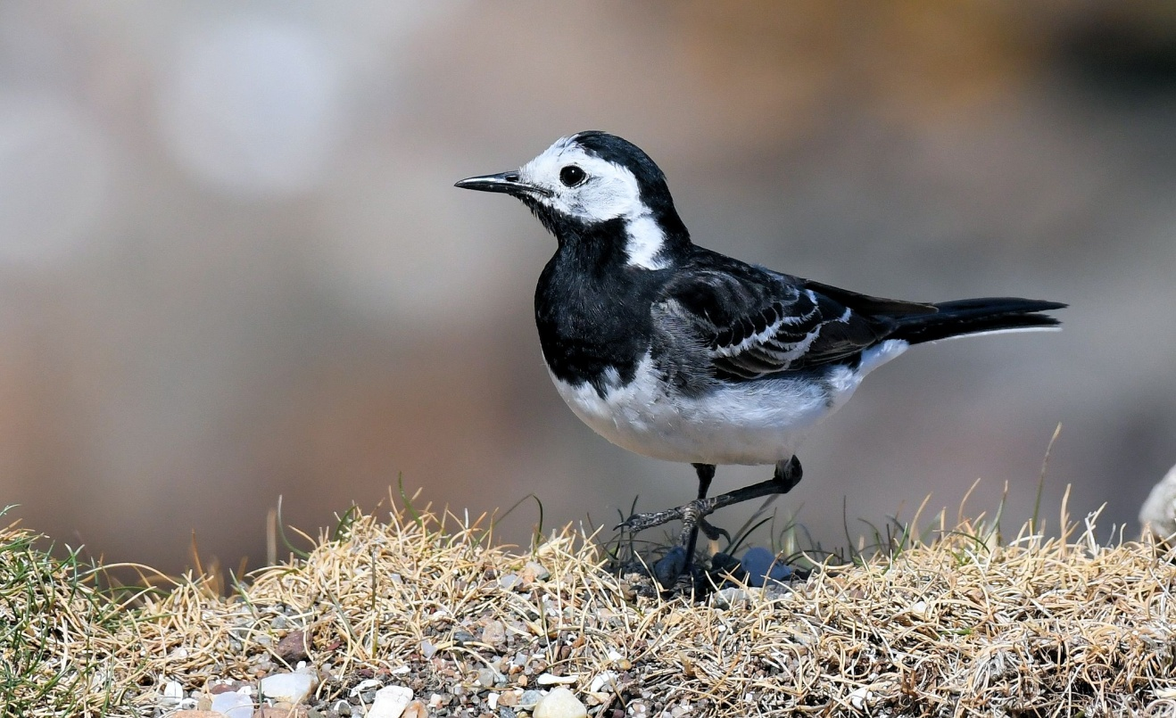
Male Pied Wagtail by nest site at MSBO 30th June

Common Linnet
Breeding; a pair with 3 fledglings on 2nd. A male was present 6th – 8th with 2 there on 10th.

A few more photos taken at MSBO during June...

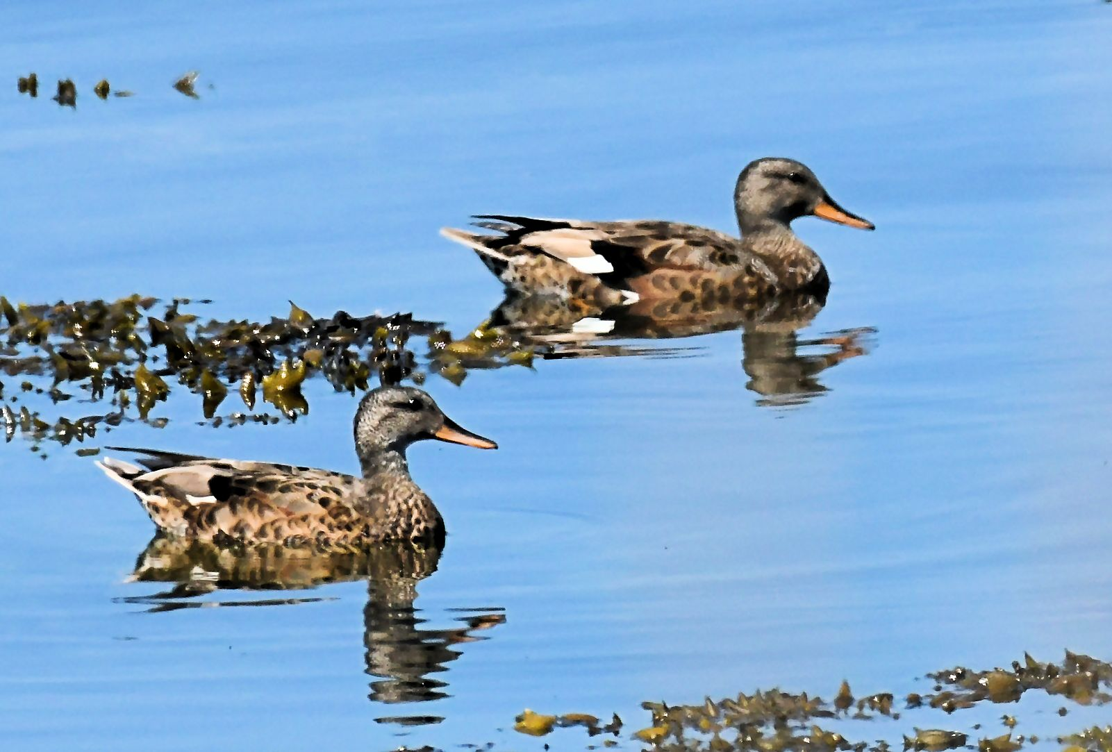
Gadwall: eclipse males 29th June
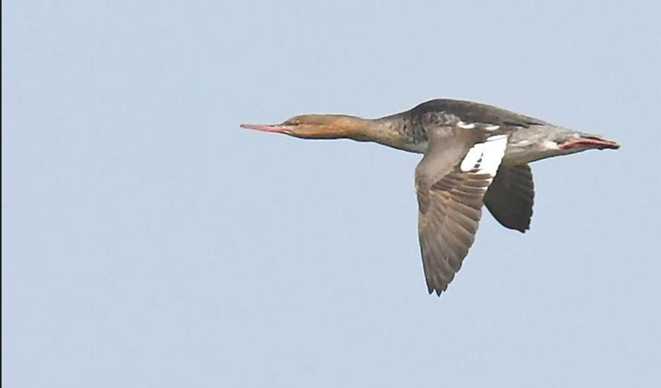
Red-breasted Merganser 4th June

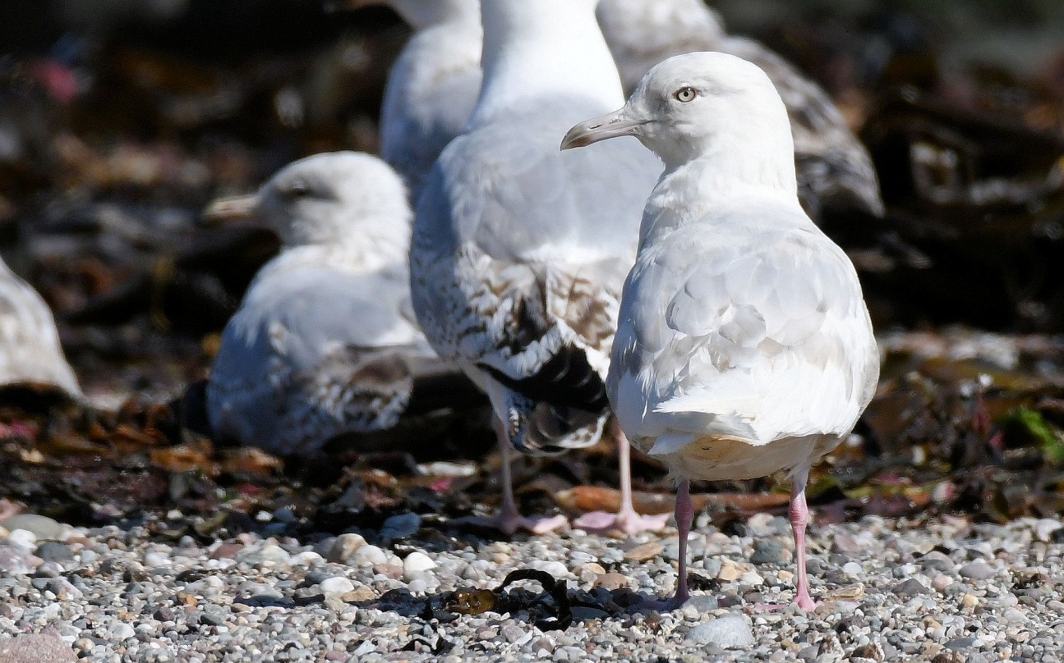
2CY Iceland Gull 20th June
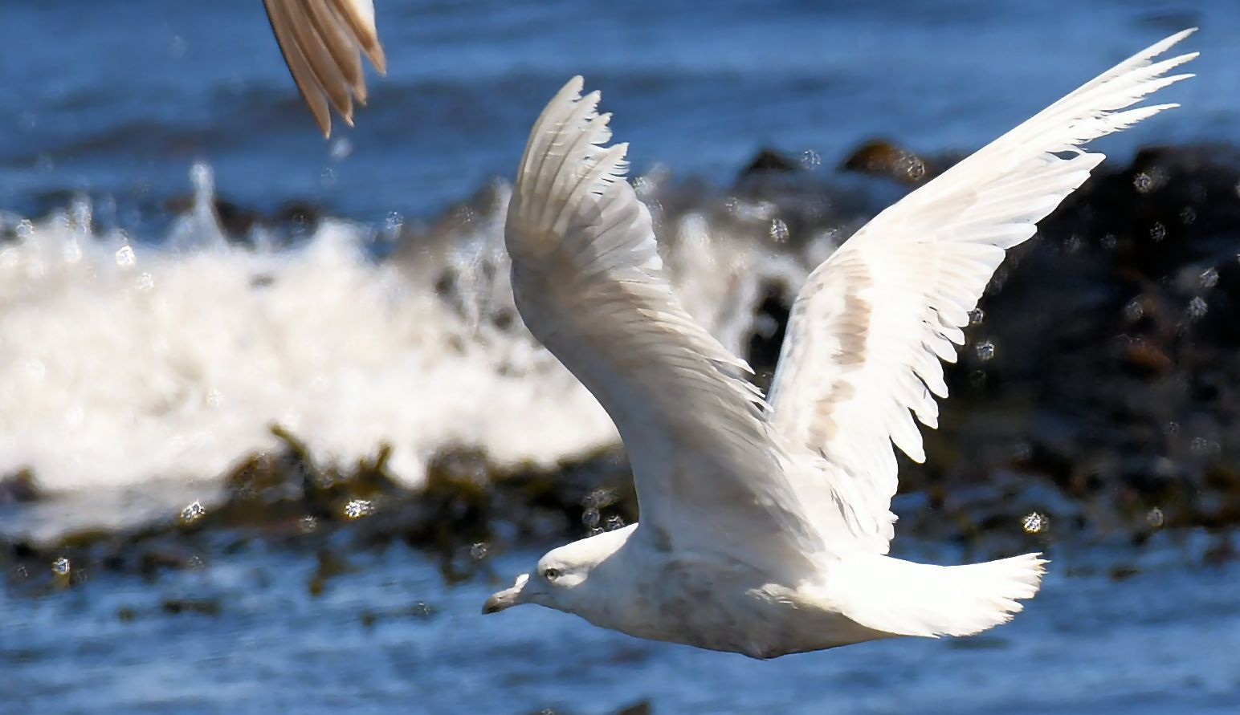
2CY Iceland Gull 20th June

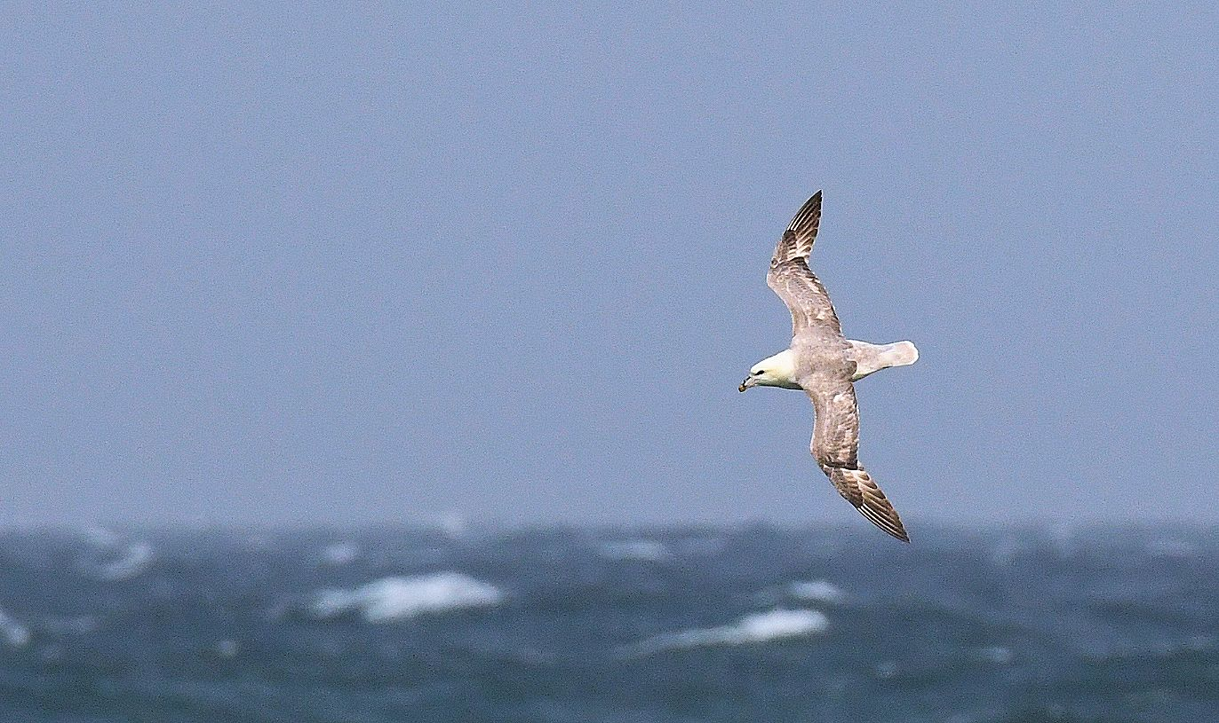
Fulmar 14th June

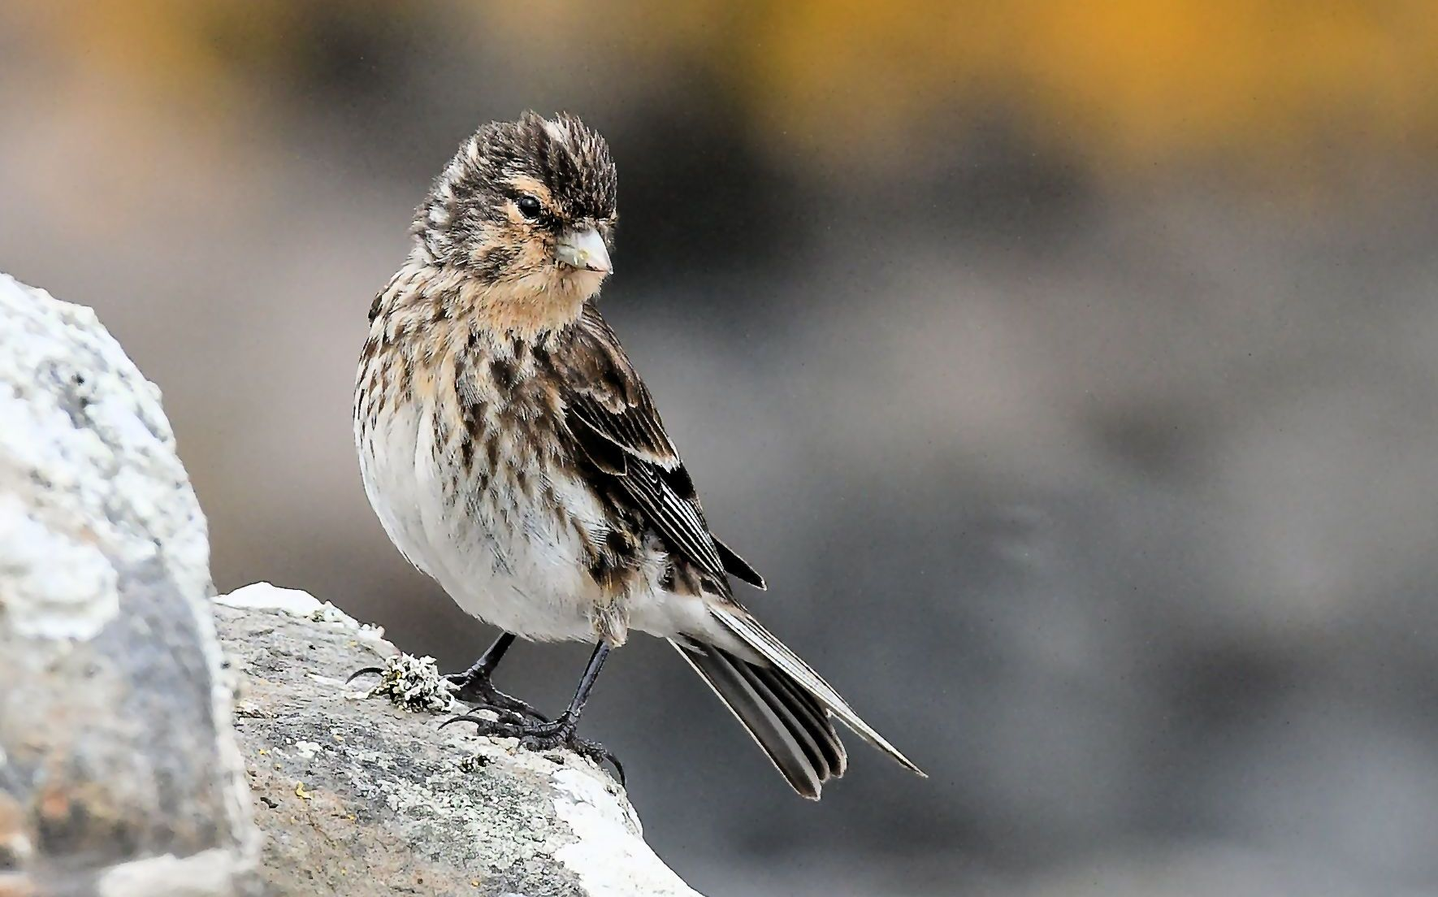
Twite 19th June

